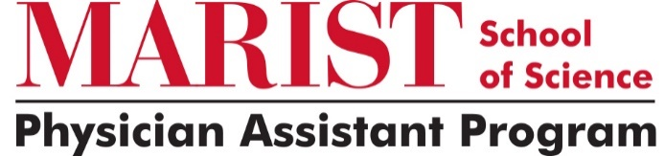

ADMISSIONS POLICY
In response to the COVID-19 pandemic, the Marist College Physician Assistant Program (MCPAP) revised its admissions criteria to reflect the current challenges of our applicants. These policy changes will remain in effect for applicants applying to our incoming 2024 cohort (Summer 2024). As the educational landscape adapts to these challenges, the program will reassess the criteria for future application submissions.
PASS/FAIL
If applying for the Summer 2024 cohort, pre-requisite pass/fail course(s) completed during the Spring 2020 and/or Summer 2020 semesters will be evaluated on an individual basis. Pass/fail courses will not be calculated into the cumulative or science prerequisite GPAs and will be evaluated as stand-alone courses. If an applicant is not given an option to receive a letter grade for a prerequisite course during Spring 2020 or Summer 2020, written documentation from their institution will need to be provided and submitted to the Office of Graduate Admission. If an applicant has the option of earning a letter grade instead of a pass/fail or satisfactory/unsatisfactory grade, prerequisite coursework should be taken on a letter-grade basis.
ONLINE LABS
Online labs will be accepted for prerequisite coursework completed during the Spring 2020 and Summer 2020 semesters, please refer to the “PASS/FAIL” criteria for grading.
DIRECT PATIENT CARE HOURS
The Physician Assistant Program will continue to require a minimum of 500 patient care hours.

