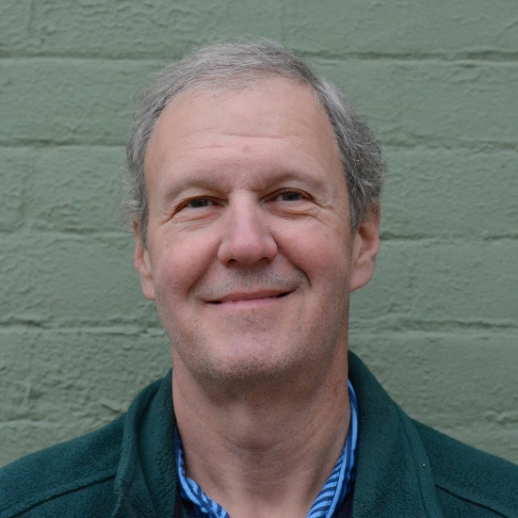

**Al Bartosic**

**Executive Director-Fordham Foundry**

Executive Director of Fordham Foundry. Serial entrepreneur with multiple exits. Current Angel investor/board member