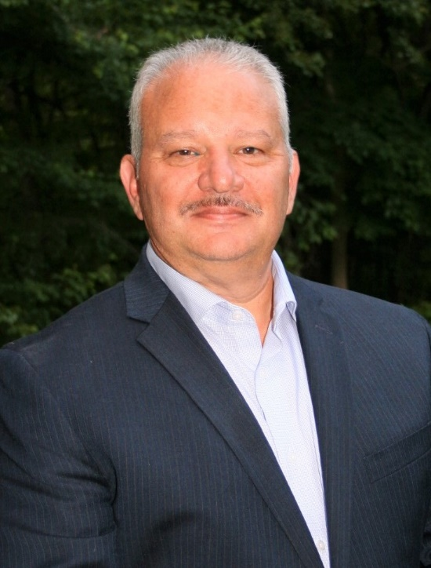

**Dean Michael**

**President of Hometown Premier Agency LLC**

I have been a business owner for over 30 years. I was a SCORE Business counselor for 10 years and taught a class at Dutchess Community College for 10 years on starting a business.